NEXTGEN ENGINEERING SOLUTIONS

ENGINEERING | PRODUCTS | SERVICES

COMPANY PROFILE

Company Overview
NextGen Engineering Solutions, we provide cutting-edge engineering services designed to address the unique challenges of modern industries. Whether you are looking to optimize operations, streamline processes, or implement innovative technologies, we are here to help you achieve your goals.

About Us
At NextGen Engineering Solutions, we specialize in providing innovative and customized engineering services to businesses seeking practical, sustainable, and cost-effective solutions. Whether you're a start-up or an established enterprise, our goal is to help you navigate complex engineering challenges and optimize your operations.
Founded in 2025, NextGen was created with a vision to blend cutting-edge technology with expert engineering to deliver solutions that not only meet today’s demands but also anticipate future needs. Our team consists of seasoned professionals from diverse engineering disciplines, including mechanical, electrical, civil, and Metallurgist, who work collaboratively to create tailor-made solutions that drive efficiency and productivity.
We take pride in our hands-on approach, working directly with clients to understand their unique challenges and deliver results that exceed expectations. Our core values—innovation, collaboration and integrity—guide everything we do, and we are committed to maintaining the highest standards of quality in all of our projects.
As we continue to grow, NextGen aims to expand its services to new industries, providing engineering solutions that are both practical and forward-thinking.
Ready to solve your engineering challenges? Contact us today to learn how NextGen Engineering Solutions can support your business.

Core Capabilities & Services
- Mechanical and Piping Engineering & Design.
- Civil and Structural Engineering & Design.
- PE Seal & Stamping for Tank, Structural and etc.,
- Root Cause Analysis for Pressure Parts Tube/ Pipe/ Other parts failures.
- Residual Life Assessment (RLA) for boiler.
- Troubleshooting of high-capacity boilers site issues.
- Boiler fatigue life calculations as per EN 12952-3 code for flexible operation of thermal power plant.
- Corrosion, erosion and wear resistant thermal spray coatings for Boiler application.
- Design of Li ion battery for electric vehicle and design and development of electric bus.
- Tekla Modelling of Buckstay.
- Mechanical Equipment & Piping Detailing and Shop Drawings.
- Structural Detailing and Shop Drawings.

Capabilities & Services
- Mechanical and Piping Engineering & Design
Mechanical and piping engineering form the backbone of industrial infrastructure, where design precision, system reliability, and compliance with international codes are crucial for project success. At NextGen Engineering Solutions, we specialize in providing end-to-end engineering solutions in mechanical and piping design, supporting industries such as power generation, oil & gas, process plants, and infrastructure development.
With a focus on innovation and accuracy, our engineering team delivers optimized layouts, detailed fabrication drawings, and validated stress analyses to ensure the safe, efficient, and cost-effective operation of mechanical systems. From the design of pressure vessels and heat exchangers to complex piping networks and support systems, our services are built around the latest tools and global standards such as ASME, IS, API, and IBR.
Our integrated approach combines mechanical design, piping analysis, CAD modelling, and field-based practicality—making us a trusted partner in the successful execution of both greenfield and brownfield engineering projects. In this, NextGen’s core discipline, we can offer a high value service in the following areas:

Mechanical Design
- Equipment Design: Expertise in boilers, heat exchangers, pressure vessels, and tanks using international codes (ASME, IS, API, etc.).
- Valve Specification: we provide detailed valve specifications tailored to project requirements, service conditions, and applicable standards. Our valve selection process considers key factors such as pressure rating, temperature limits, fluid properties, operation mode, and installation environment.
- Structural Design: Layouts and fabrication drawings for steel structures, platforms, and pipe racks.
- Stress & FEA Analysis: Simulation-based validation for components under pressure, load, and thermal conditions. Static & dynamic (vibration) structural analysis by using ANSYS. Steady state & Transient thermal analysis by using ANSYS.
- Acoustic analysis in boiler.
- CFD Analysis: CFD (Computational Fluid Dynamics) Analysis is a powerful tool used to simulate and analyse fluid flow behaviour, heat transfer, and other physical phenomena within a given system. It plays a crucial role in engineering design, process optimization, and troubleshooting by using ANSYS Fluent.
- Material Engineering: Optimized material selection based on mechanical properties, corrosion resistance, and cost-effectiveness.
- CAD Modelling: 3D modelling and 2D detailing using AutoCAD, SolidWorks, and similar platforms.
CFD analysis
Computational Fluid Dynamics (CFD) is a branch of fluid mechanics that uses numerical simulation techniques to analyse and predict fluid flow, heat transfer, chemical reactions, and related physical phenomena. By solving the governing mathematical equations of fluid motion (Navier-Stokes equations), CFD enables engineers to visualize and optimize the performance of systems involving gases, liquids, or multiphase flows.
At NextGen Engineering Solution, we offer advanced CFD modelling and simulation services to support the design, evaluation, and optimization of industrial components and processes across sectors like power, process, HVAC, automotive, and energy.
Case 1: Multi-Port Square Pitot tube airflow Measuring device | 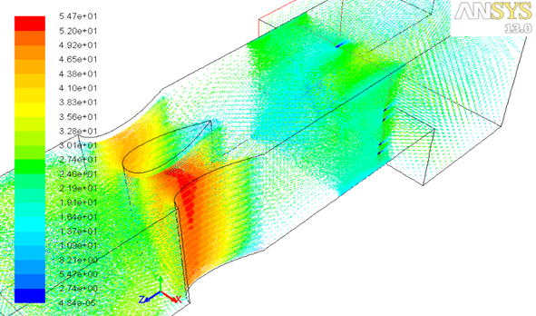
Case 2: Effects of Baffle Plates in Boiler Flue Gas Duct | 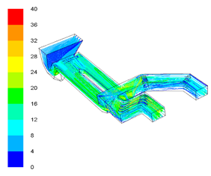
CASE 3: Thermal management system of Li ion battery pack | 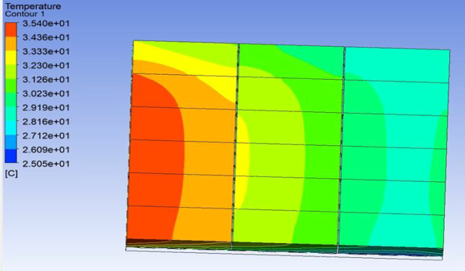
CASE 4: Effect of thermal interface in Heat Transfer | 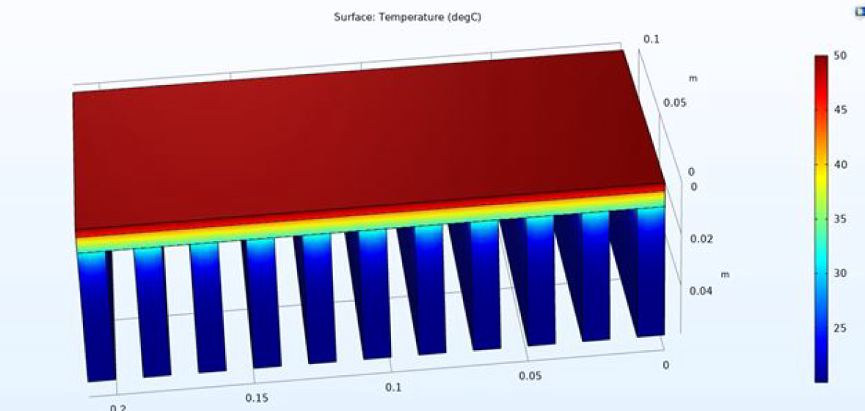
CASE 5: Transient Thermal Analysis - Disc and Drum Brake Foundation | 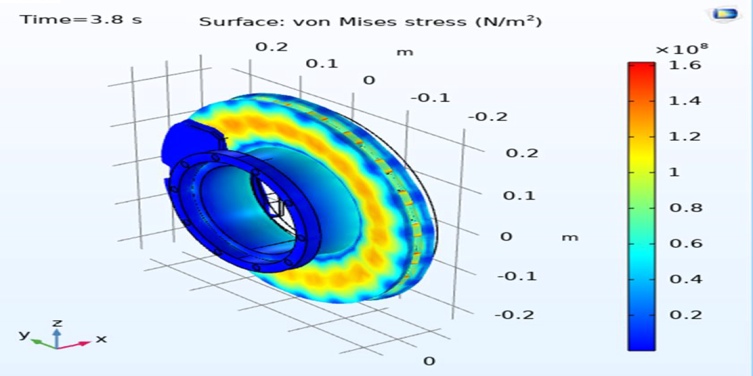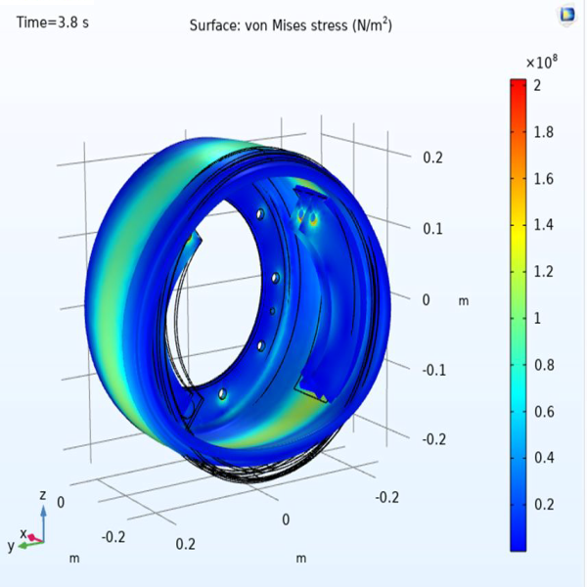

Static Structural Analysis
Static Structural Analysis is a fundamental engineering technique used to determine the response of structures and mechanical components to applied loads under static (non-changing) conditions. It involves evaluating stresses, strains, deformations, and support reactions when a structure is subjected to forces such as dead loads, live loads, thermal effects, and pressure—without considering dynamic or time-varying effects.
At NextGen Engineering Solution, we use advanced FEA (Finite Element Analysis) tools to perform static structural simulations that ensure design integrity, safety, and compliance with engineering standards across industries such as power, process, oil & gas, heavy machinery, and infrastructure.
Case 1: Structural Analysis of e-Bus Monocoque Chassis | 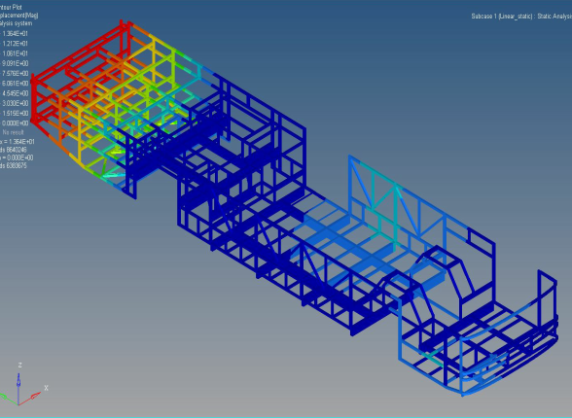
Case 2: Boiler Ceiling Girder | 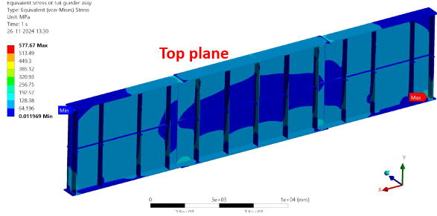
Case 3: Vertical Buckstay Attachment | 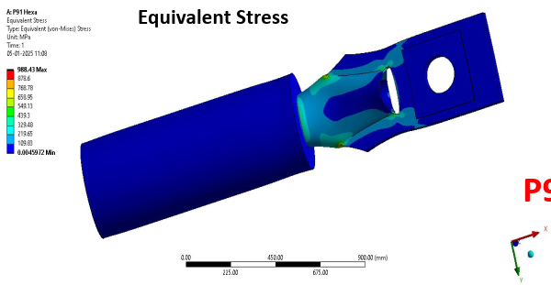
Case 4: Design and Stress analysis of mounting brackets | 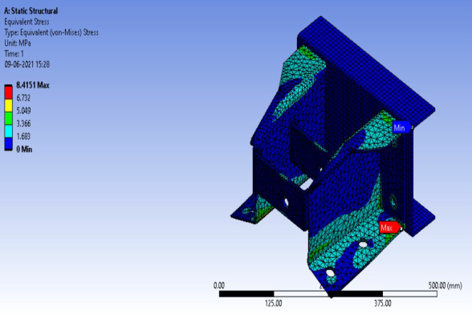
Case 5: Electric Bus Leaf Spring Stress Analysis | 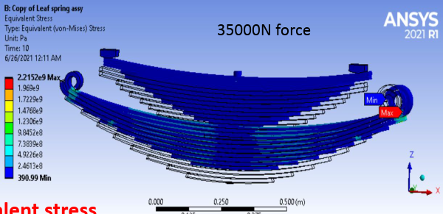
Case 6: Low Floor Front Axle Stress Analysis | 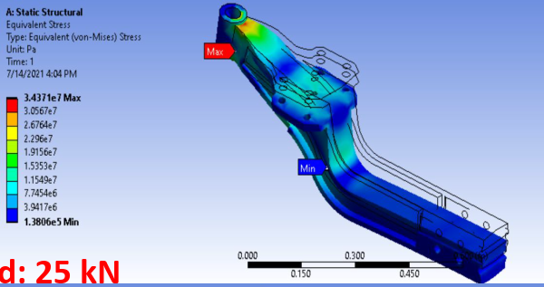
Case 7: Cow horn Air Suspension rear axle Stress Analysis | 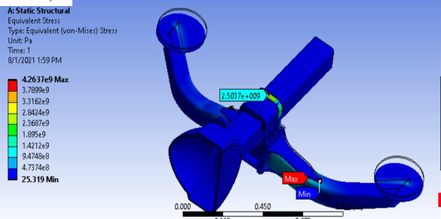

Design of Pressure Vessel by using PV Elite
Pressure vessels are critical components used in process, chemical, power, and petrochemical industries for holding gases or liquids at a pressure substantially different from ambient pressure. The design, analysis, and validation of these vessels require adherence to stringent international codes and standards, such as ASME Section VIII Div. 1 & 2, to ensure safety, reliability, and performance.
At NextGen Engineering Solution, we leverage PV Elite, a leading pressure vessel design software developed by Hexagon, to deliver code-compliant, optimized, and fabrication-ready pressure vessel designs for a wide range of industrial applications.
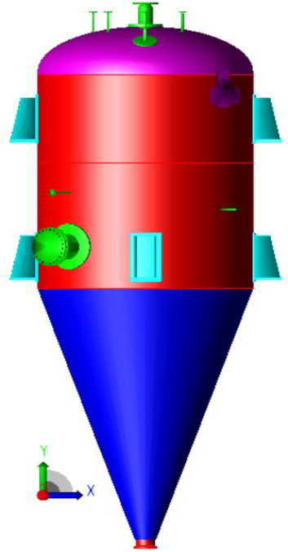 | 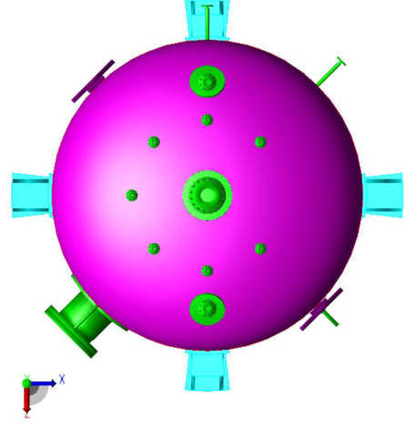

Design of Storage Tank by using Tank software
Storage tanks are essential components in the oil & gas, chemical, petrochemical, and power industries for storing large volumes of liquids such as crude oil, fuel, chemicals, and water. Their design must meet stringent safety, operational, and environmental standards. To ensure code compliance, structural integrity, and cost-effectiveness, specialized software tools are employed in the engineering process.
At NextGen Engineering Solution, we use TANK—a dedicated software by Hexagon—for the design, analysis, and evaluation of aboveground storage tanks in accordance with API 650, API 620, and API 653 standards. This enables us to deliver robust and optimized designs for atmospheric and low-pressure storage systems.

Piping Engineering
- Plant and Piping Layout & Routing: Development of efficient piping systems with clash-free 3D layouts.
- P&ID & GA Drawings: Comprehensive process schematics and general arrangement plans.
- Pipe Stress Analysis: Using tools like CAESAR II to ensure code compliance under operating loads.
- Pipe Support & Hanger Design: Primary and secondary support selection based on load cases. Spring, rigid, guide, anchor supports with location plan and installation data.
- Boiler & Piping Lug Attachment: Design of Boiler & Piping lug attachment.
- Isometric Drawings and BoM: Clear and fabrication-ready isometrics with material take-offs (MTO/BOM).
Piping Supports for Steam Generating units
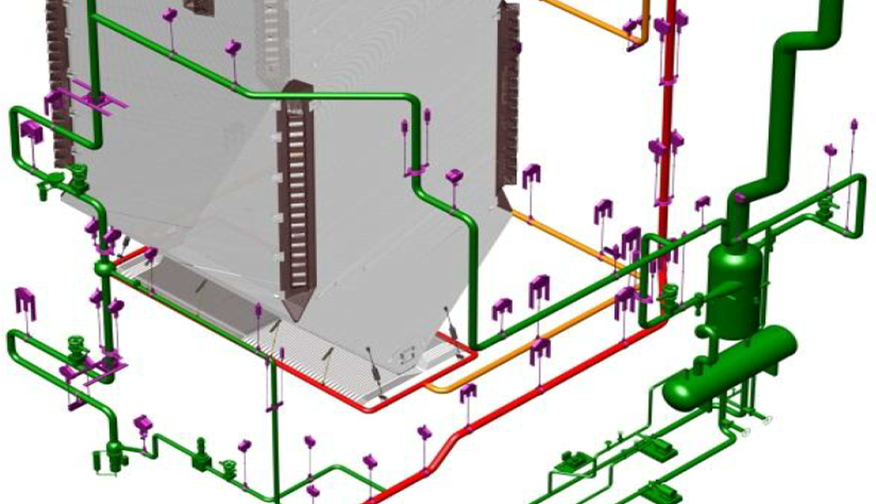

CAESAR II analysis for Piping Supports
CAESAR II is the industry-leading software used for pipe stress analysis, enabling engineers to evaluate the flexibility, loads, and structural integrity of piping systems under various operating conditions. Developed by Hexagon, CAESAR II helps assess how thermal expansion, pressure, weight, and dynamic loads affect piping and its associated supports, ensuring compliance with design codes and long-term operational safety.
At NextGen Engineering Solution, we use CAESAR II to analyse critical piping systems and provide optimized support design to control movement, minimize stresses, and prevent failure across power plants, refineries, chemical facilities, and other industrial projects.
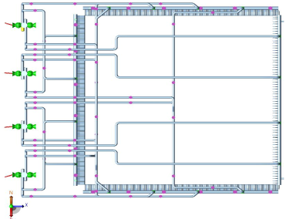
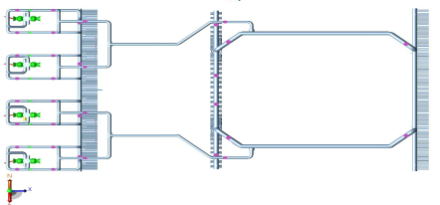
CAESAR II analysis for Boiler Coil Supports
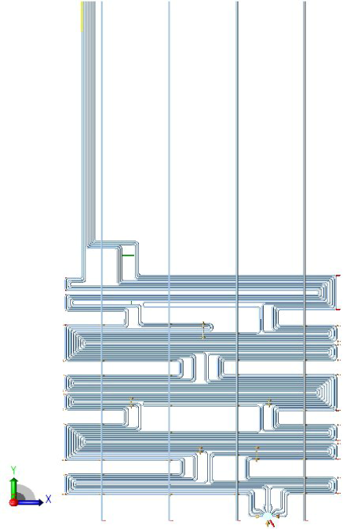

- Civil and Structural Engineering & Design
Civil and Structural Engineering forms the foundation of safe, durable, and functional infrastructure. At NextGen Engineering Solution, we offer end-to-end services in structural analysis, detailing, and civil works design—delivering optimized, code-compliant solutions for industrial, commercial, and infrastructure projects.
Our team integrates field experience, advanced engineering software, and deep knowledge of national and international codes to ensure each structure performs reliably under operating, seismic, and environmental loads.
Civil Engineering Design
- Architectural & Layout Planning for Industrial and Utility Buildings.
- Earthwork & Land Development Plans, Drainage, Roadway Layouts and Car parking design.
- Utility Duct Banks, Cable Trenches, and Earth Pits.
Structural Engineering
- RCC & Steel Structure Design (IS 456, IS 800, AISC, BS Codes).
- Structural Analysis & Load Calculations.
- Foundation Design (Isolated, Raft, Pile, Combined).
- Industrial Building & Equipment Support Structures.
- Module/Skid Structural Design.
- Water Retaining Structures Design.
- Seismic & Wind Load Design.
- Retaining Walls, Water Tanks, Silos, Pipe Racks.
PE Seal & Stamping for Structural
- Construction Surveillance & Certification.
Design Standards & Codes
Main Engineering Standards utilised include AISC, ACI 318, ACI 350, ASCE 7, IBC, OSHA & NFPA.
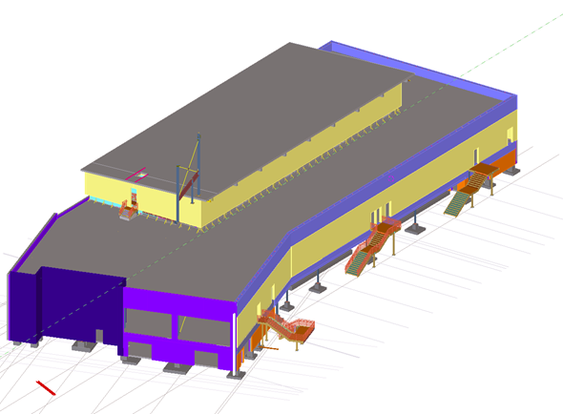
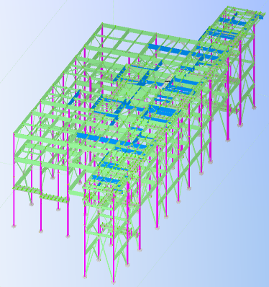
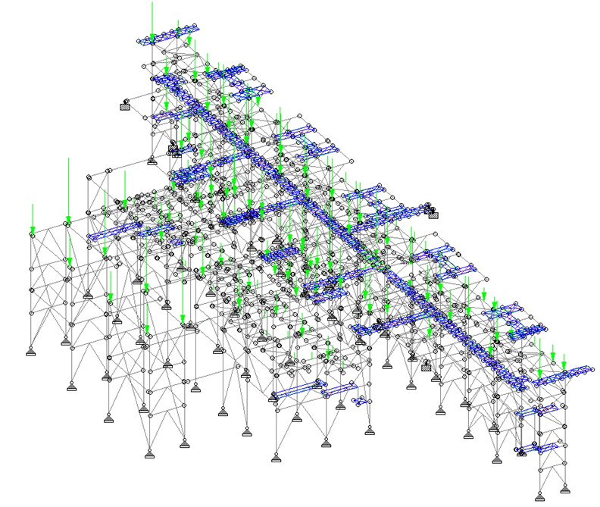
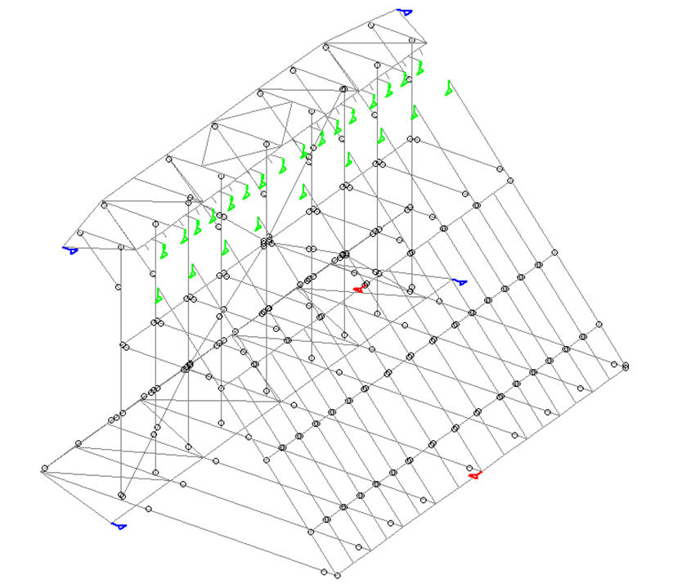

- Root Cause Analysis for Pressure Parts Tube/ Pipe/ Other parts failures
Boiler pressure parts—including tubes, pipes, headers, drums, and fittings—are critical to safe and efficient plant operation. Failures in these components can lead to unplanned shutdowns, safety hazards, and economic loss. A systematic Root Cause Analysis (RCA) helps identify the true source of failure and guides corrective and preventive actions.

Mechanism of FRH ASS failures
Sl No | Properties | Non stabilized ASS (304L, 316L) | Non stabilized ASS (304H, 316H) | Stabilized ASS with coarse grain + Shot Peening (TP321H, TP347H, UNS S30432) | Stabilized ASS with Fine grain + Shot Peening (TP347HFG & UNS S30432 fine grain)
01 | Creep | Poor Creep properties & elevated tensile strength due to low carbon. | Improve Creep properties  - Only Coarse grain.  - Intergranular Cr₂₃C₆ form. | Improve Creep properties  - Coarse Grain.  - NbC precipitation. | Improve Creep properties  Only NbC precipitation.
02 | Oxidation Resistance | - Low Oxidation resistance due to Fe₃O₄/ (Fe,Cr)₃O₄ oxide spinal layer formation.  - High exfoliation. | - Low Oxidation resistance due to Fe3O₄/ (Fe,Cr)3O₄ oxide spinal layer formation.  - High exfoliation. | - Medium Oxidation resistance due to Fe₃O₄/ (Fe,Cr)₃O₄ oxide spinal layer formation.  - Medium exfoliation. | - Good oxidation resistance due to Fe₃O₄/ (Fe,Cr)₃O₄/ Cr₂O₃ oxide layer formation.  - Low exfoliation.
03 | Contaminant | - The concentration of moisture and chloride ion at tube inside surface locally depassivates (break-down) the ultra-thin protective passive film (oxide film) on stainless steel.  - Accelerate the corrosion.
04 | Sensitization/ IGC | Low susceptible to sensitization (carbide formation). | High susceptible to sensitization (carbide formation). | Low susceptible to sensitization (carbide formation). | Low susceptible to sensitization (carbide formation).
05 | Pitting corrosion | Low and contaminant accelerate the corrosion. | High and contaminant accelerate the corrosion. | Medium and contaminant accelerate the corrosion. | Low and contaminant accelerate the corrosion.
06 | SCC | Low (IGC + Contaminant + All stress +Creep cavity) | High (IGC + Contaminant + All stress). | Medium (IGC + Contaminant + All stress). | Low (IGC + Contaminant + All stress).
07 | SRC | No (Precipitation + Residual Stress). | No (Precipitation + Residual Stress). | High (Precipitation + Residual Stress). | High (Precipitation + Residual Stress).

Case 1: SH choking due to sea water in Boiler circuit | 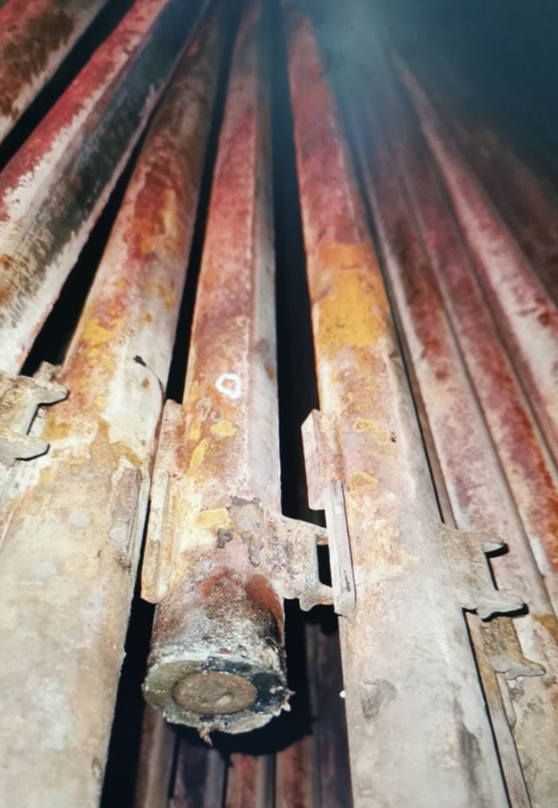
Case 2: HRH piping vent  - This is start up vent of HRH piping. Its frequently failed twice, when we analysed it was found the pipe was welded rigidly in 2 places without giving sufficient thermal expansion.  - Once we provided a 3D loop in that place then the problem resolved. | 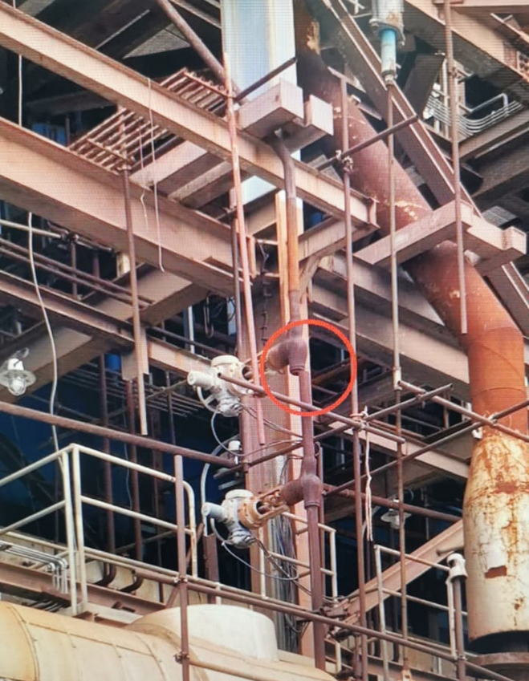
Case 3: SA duct failed after APH waterwash | 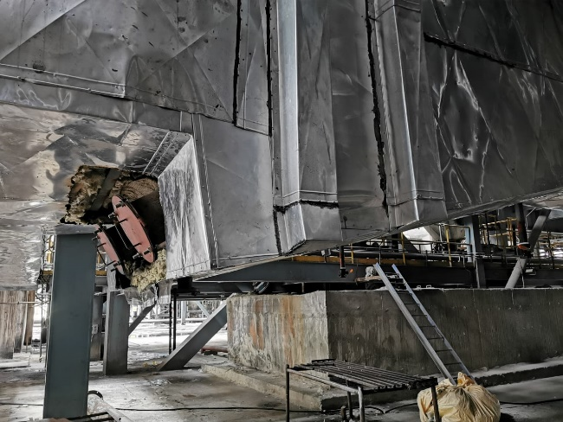
Case 4: Ash accumulation on Boiler extended floor panel.  - Ash started to accumulate over extended floor panel, after analysing gas flow and site condition it was suggested to provide a soot blower over there.  - The soot blower with higher pressure and adjustable spray angle. This resolved the ash accumulation issue. | 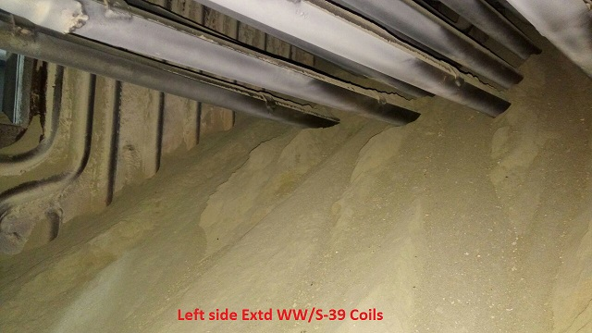  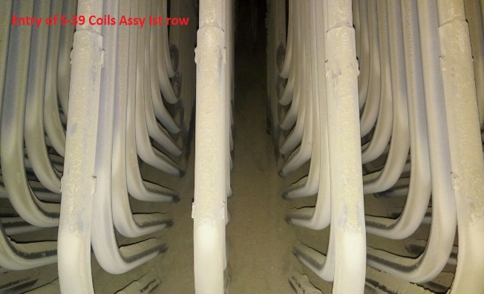

- Residual Life Assessment (RLA) for boiler
Residual Life Assessment (RLA) of a boiler is a systematic engineering process to evaluate the remaining safe operating life of its pressure parts and structural components after years of service. This is critical for boilers that have operated beyond 100,000–200,000 hours or are nearing the end of their design life (typically 20–25 years). RLA helps determine whether components can be operated safely, need repair, or require replacement.
At NextGen Engineering Solution, we conduct comprehensive RLA studies for utility, industrial, and process boilers, combining site inspection, material evaluation, and engineering analysis to support life extension, safety assurance, and regulatory compliance.
Why Choose NextGen Engineering Solution?
- Outsourced NDT, metallurgical, and stress analysis expertise.
- Experience with design of subcritical, supercritical, and HRSG boilers.
- Code compliance with IBR, ASME, and API 579.
- Accurate documentation and support for statutory clearances.
- Practical, cost-effective repair and replacement recommendations.

- Thermal Spray Coatings for Boiler application
Boiler components, especially in high-temperature and corrosive environments such as furnace walls, superheaters, reheaters, and economizers, are subject to accelerated wear, erosion, oxidation, and high-temperature corrosion. To enhance the service life and performance of these pressure parts, thermal spray coatings are increasingly applied as a protective surface treatment.
Thermal spray processes deposit metallic or ceramic-based coatings onto boiler tube surfaces to form a barrier against harsh combustion gases, ash erosion, and chemical attack—without altering the base material microstructure.
Case 1: Nano-crystalline non-stick coating to prevent slagging and improve heat transfer in Boiler Water Wall | 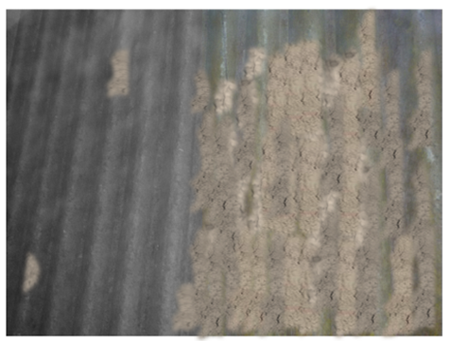
Case 2: Sea Water Corrosion resistant Coating for Boiler Water Wall.  Monthly once shutdown was observed before application of coating. The shutdown frequency was drastically reduced due to this coating. A coating thickness reduction of 10-20 micron was observed. | 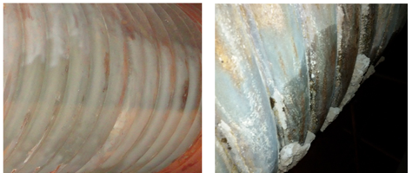
Case 3: Laser Surface Melting for Boiler ID fan blade to prevent Flue Gas erosion | 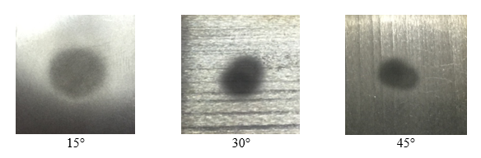

- Capabilities in E bus design and development
With the global shift toward sustainable mobility, electric buses (E-Buses) are transforming public transportation by offering clean, efficient, and low-emission alternatives to traditional diesel fleets. At NextGen Engineering Solution, we provide end-to-end engineering support for E-Bus design, development, and integration — combining expertise in mechanical, electrical, and embedded systems with vehicle simulation and manufacturing support.
- Vehicle Architecture & System Design
- EV powertrain configuration: hub/central motor, differential, transmission integration.
- Layout planning: Battery pack placement, motor position, and weight distribution.
- Modular platform development for various bus sizes (7m, 9m, 12m).
- Battery Pack Design
- Selection of Li-ion / LFP / NMC cells based on range, safety, and lifecycle.
- Pack engineering: cell stacking, BMS integration, thermal insulation, and enclosure design.
- Design for cooling systems: air/liquid-based thermal management.
- Electric Drivetrain Design
- PMSM Motor specification & integration.
- Controller tuning, inverter compatibility, and regenerative braking logic.
- Drive cycle simulations (e.g., MIDC, UDDS) for performance validation.
- Body Structure & Chassis Engineering
- Monocoque/ Ladder frame chassis.
- Crashworthiness, rollover protection, and NVH optimization.
- Bus frame and suspension design (air/leaf spring, low-floor accessibility).
- Thermal Management System (TMS)
- Integrated thermal system for motor, inverter, and battery.
- HVAC system design for cabin cooling with minimal power draw.
- Simulations for cooling/heating profiles in various climates.
- Charging System Integration
- Compatibility with AC (slow) and DC fast charging infrastructure.
- CCS2 or GB/T charging port selection and controller integration.
- On-board charger (OBC) capability assessment.
- Electrical & Embedded Systems
- Wiring harness design (low and high voltage).
- BMS, VCU, and telematics integration.
- CAN/LIN communication and diagnostic protocols.
- Safety logic as per ISO 26262 (Functional Safety).
- Simulation & Testing Support
- Vehicle range and energy consumption simulations.
- Thermal analysis (battery/motor/cabin).
- EMI/EMC planning and fault analysis.
- Durability & fatigue testing models.
- Homologation assistance (AIS 038, AIS 156, CMVR).
Capabilities in E bus design and development
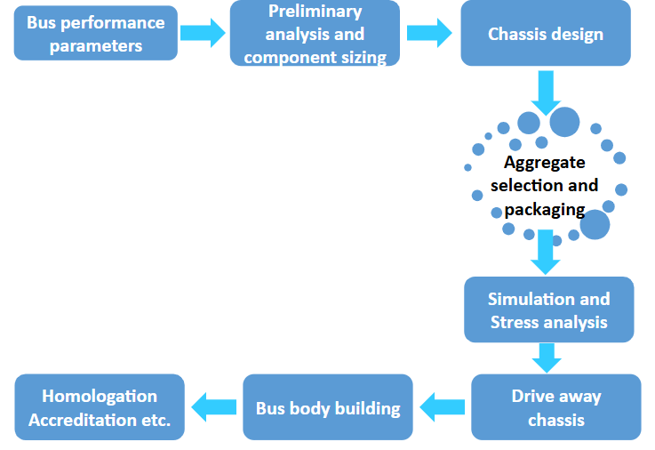

Design capabilities of Monocoque Chassis for Electric Bus
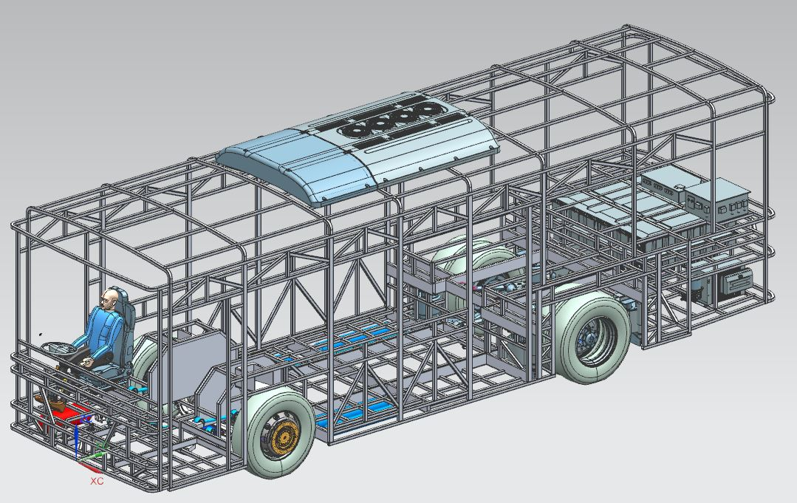
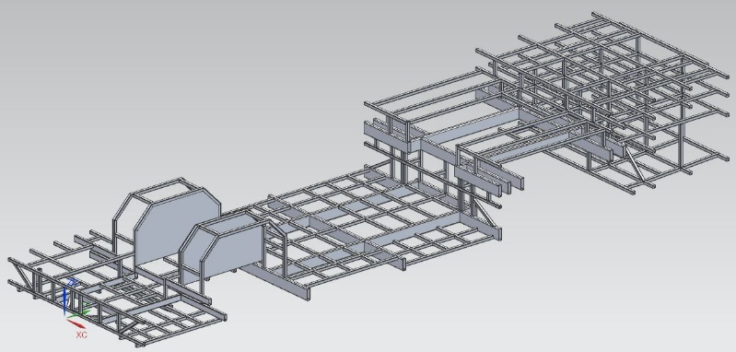 | 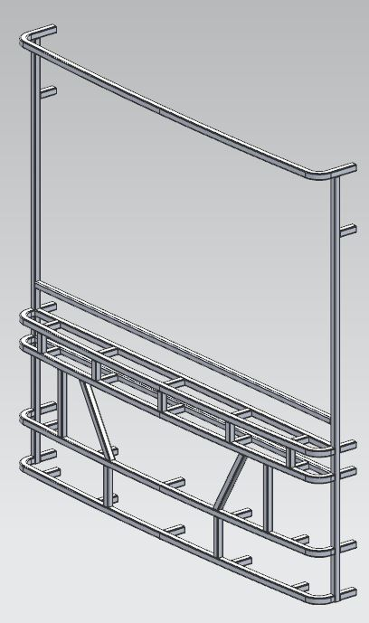
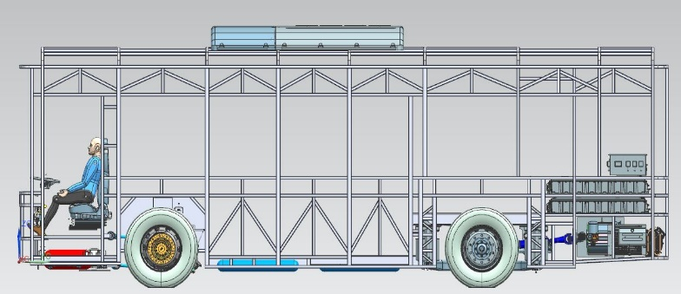 | 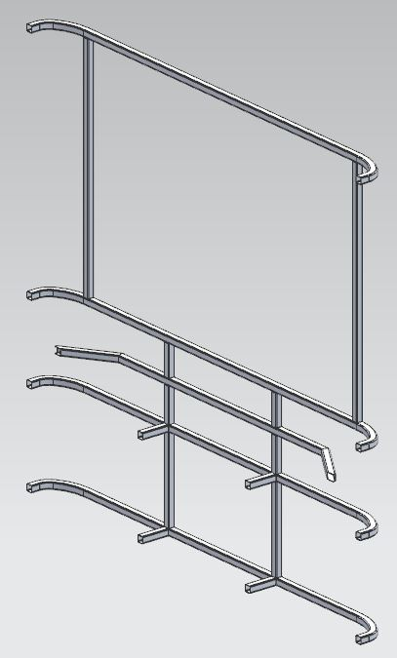

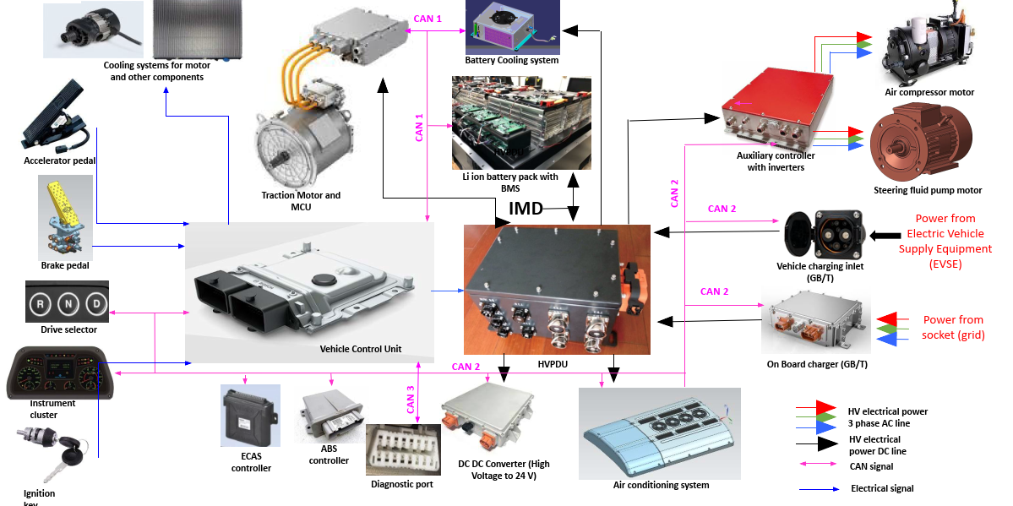
Powertrain integration in electric bus

- Tekla Modelling of Buckstay
In large industrial boilers, especially those used in thermal power plants, the buckstay system is a critical structural component that provides lateral support and stiffness to the boiler’s membrane walls. Accurate modeling and detailing of buckstays in Tekla Structures ensures structural integrity, optimized fabrication, and clash-free erection at site.
At NextGen Engineering Solution, we utilize Tekla Structures to develop highly accurate 3D models of buckstay assemblies, fully integrated with boiler steelwork, hanger systems, and supporting structures. Our expertise ensures compliance with design codes, fabrication feasibility, and site constructability.

- Structural Detailing and Shop Drawings
At NextGen Engineering Solution, we provide accurate and code-compliant structural detailing services, ensuring that every component is represented with precision and aligned with construction best practices.
Our detailing team works closely with structural designers and fabricators using industry-standard software like Tekla Structures, AutoCAD, and Revit to generate shop-ready, clash-free, and fabrication-optimized drawings for industrial, commercial, and infrastructure projects.
  - Steel Structure Detailing
- 3D Modeling of steel frames, platforms, pipe racks, and supports.
- Connection detailing: bolted, welded, or hybrid.
- Anchor bolt plans and base plate detailing.
- Ladder, staircase, handrail, and grating detailing.
- Built-up sections and bracing systems.
- Erection sequences and part identification (marking plans).
  - RCC Structure Detailing
- Reinforcement detailing for slabs, beams, columns, and footings.
- Retaining walls, water tanks, and machine foundations.
- Bar Bending Schedules (BBS) with cut lengths.
- Expansion joint detailing, rebar lap lengths, and bend shapes.
- Precast and cast-in-situ element drawings.
  - Shop Drawings
- General Arrangement (GA) Drawings.
- Assembly and Single-Part Drawings.
- Material Take-Off (MTO) & Bill of Materials (BOM).
- Weld maps, bolt list, and fabrication notes.
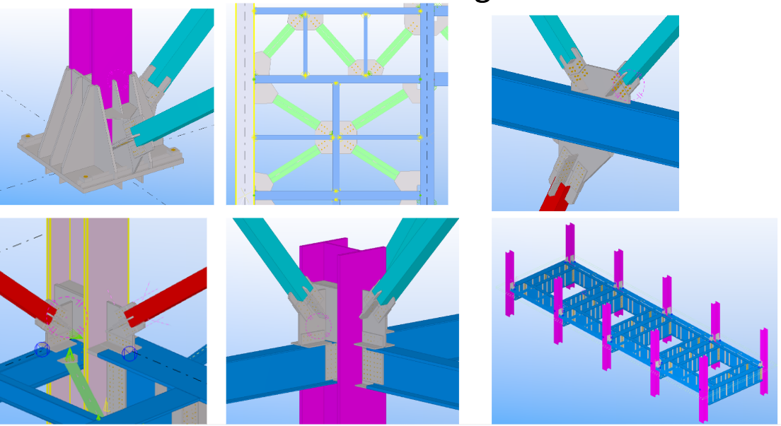
Software
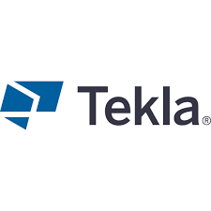 | 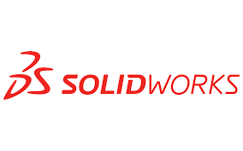 |  | 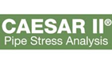 | 
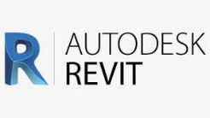 | 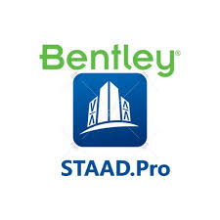 |  | 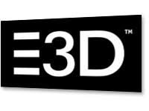 | 
 | 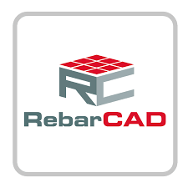 |  |  | 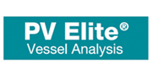
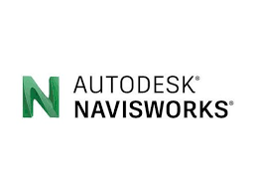 | 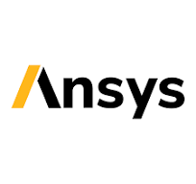 |  |  | 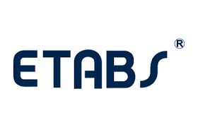

Our clients
 | 

Contact Us
NextGen Engineering Solutions
43, 4th CROSS, GOKULA NAGAR EXTN, KATTUR,
TIRUCHIRAPPALLI -620019, TAMIL NADU, INDIA.
MOBILE: +91-9025332603
E MAIL: info@nextgenengg.com
Website: www.nextgenengg.com

